AGREGAR UN SP A UN ROL

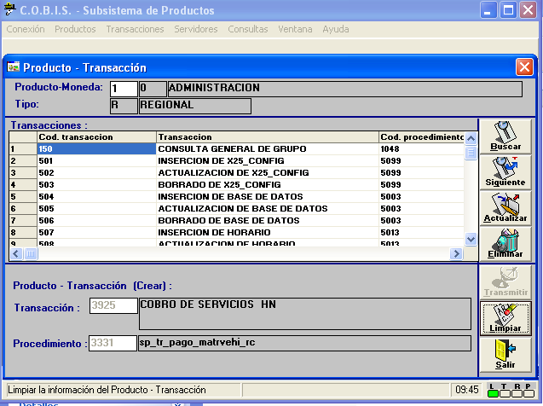

declare @w_trn int
select @w_trn = 3925
select * from cobis..ad_pro_transaccion where pt_transaccion = @w_trn

